TEMPORARY PACING – WHEN AND HOW?

DR. R. VIJAYAKUMAR
Consultant Cardiac Anaesthesiologist
KG Heart Center
KG Hospital and Post Graduate Institute
Coimbatore

Pace maker is an artificial device that delivers a timed fixed electrical stimulus to the heart, which results in cardiac depolarisation. These devices keep the heart beating slow when used. The main disadvantage is that they cannot control a faster rate.
The indication for temporary pacing can be considered in two broad categories: Emergency (usually associated with myocardial infarction) and elective.
In particular, the patients presenting with sinus node disease rarely need temporary pacing.
Any patients with acute haemodynamic compromise caused by bradycardia with or without episodes of asystole should be considered for temporary pacing.
For the majority of patients, this is likely to occur in the setting of acute myocardial infarction; complete heart block with anterior infarction usually indicates a poor prognosis and a need for pacing whereas complete heart block with inferior infarction is usually reversible, associated with a narrow QRS, and responds to atropine

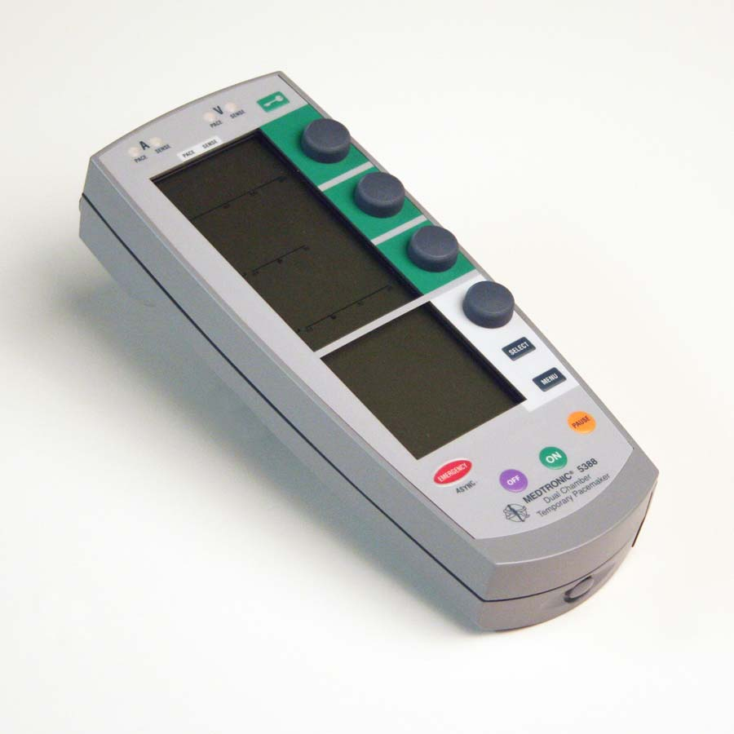
PACEMAKER PULSE GENERATOR
INDICATIONS FOR TEMPORARY TRANS VENOUS CARDIAC PACING:
EMERGENCY / ACUTE
ACUTE MYOCARDIAL INFARCTION:
- Asystole
- Symptomatic Bradycardia
- New bifascicular block with first degree heart block
- Mobitz type II AV block
BRADYCARDIA NOT ASSOCIATED WITH MYOCARDIAL INFARCTION:
- Asystole
- 2nd or 3rd degree heart block with haemodynamic compromise
- Ventricular arrhythmias secondary to bradycardia

ELECTIVE
- Supportive for the procedures that may cause bradycardia
- Cardiac surgery
- Rarely for Coronary Angioplasty ( right coronary if needed)
- Overdrive suppression for tachyarrhythmias

The placement of temporary pacing is by different routes.
- Transvenous
- Epicardial
- Transoesophageal
- Transcutaneous
TRANSVENOUS:
There are arguments in favour of and against all the major venous access sites (internal and external jugular, subclavian, brachial, femoral); each is associated with particular problems
including lead stability, infection, haemorrhage, pneumothorax, patient discomfort, etc.

Current guidelines from the British Cardiac Society recommend the right internal jugular route as most suitable for the inexperienced operator; this offers the most direct route to the right ventricle, and is associated with the highest success rate and fewest complications. This was also the recommendation of Hynes and colleagues as a result of five years of temporary pacing experience in a coronary care unit setting.

In patients receiving or likely to receive thrombolytic treatment, the femoral, brachial or external jugular are the routes of choice. It is also generally best to avoid the left subclavian approach if permanent pacing may be required, as this is the most popular site for permanent pacing
The femoral approach, which allows rapid access and easy compression in case of bleeding, is preferred

TRANSVENOUS VENTRICULAR PACING:
Positioning the temporary pacing wire requires the combination of satisfactory anatomical
and electrical data. Different venous approaches will require different techniques; probably the most important difference will be the result of approaching the right atrium from below (femoral route) or above (all other routes). The procedure needs appropriate instruments, a sterile environment, trained support staff, and good quality fluoroscopy equipment.

The lead must be advanced to the right atrium and then across the tricuspid valve. With a
temporary wire, crossing the tricuspid valve is often performed most easily by pointing the lead tip downwards and towards to the left cardiac border and advancing across the valve. The lead is then advanced to a position at the right ventricular apex.

TRANSVENOUS ATRIAL PACING:
Temporary atrial pacing leads have a preshaped J curve to enable positioning in the right atrial appendage. This necessitates approach from a superior vein and positioning is greatly assisted by a lateral screening facility on fluoroscopy. The tip of the lead should point forward with the J shape slightly opened out when slight traction is applied; unless this is achieved it is unlikely that the lead will be stable.
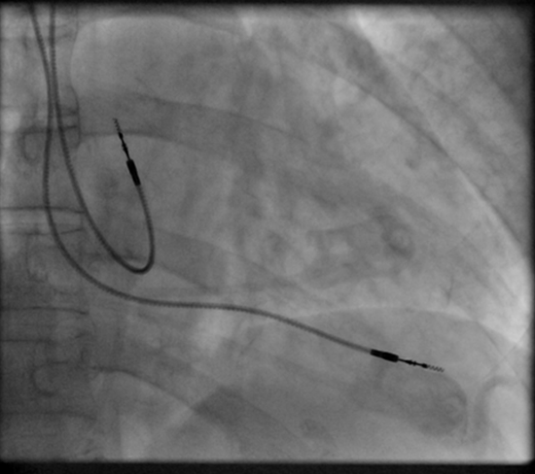
RIGHT ATRIAL AND RIGHT VENTRICULAR LEAD IN PLACE

EPICARDIAL PACING:

This route is used following cardiac surgical procedures as it requires direct access to the external surface of the myocardium. Fine wire electrodes are placed within the myocardium from the epicardial surface and the connectors emerge through the skin. These electrodes can be removed with gentle traction when no longer required; their electrical performance\ tends to deteriorate quite rapidly with time, however, and reliable sensing/pacing capability is often lost within 5–10 days, especially when used in the atrium.

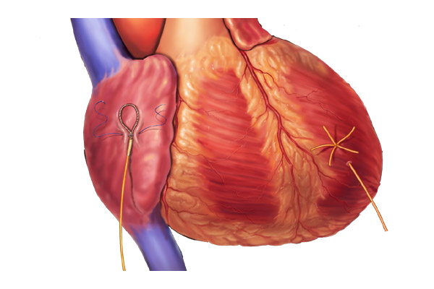
EPICARDIAL PACING WIRES IN PLACE
TRANSCUTANEOUS PACING:

This approach certainly offers a “bridge” to Transvenous approach for circumstances where the patient cannot be moved or staff with Transvenous pacing experience are not immediately available. Positioning of the transcutaneous pacing electrodes is usually in an anteroposterior configuration but if this is unsuccessful, if external defibrillation is likely to be needed or if electrodes are placed during a cardiac arrest situation, the antero-lateral configuration should be considered.
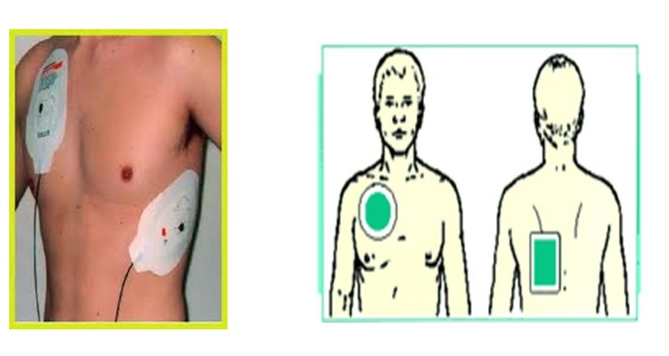
TRANSCUTANEOUS PAD PLACING

TRANSOESOPHAGEAL PACING:

The oesophageal or gastro-oesophageal approach has been advocated for emergency ventricular pacing as it may be better tolerated than external pacing in the conscious patient. Success rates of around 90% are claimed for ventricular stimulation using a flexible electrode positioned in the fundus of the stomach and pacing through the diaphragm. Transoesophageal atrial pacing (performed by placing the electrode in the mid to lower oesophagus to obtain atrial capture) is also well described. The main problem is that the electrode stability can be difficult to achieve and there is no protection against atrioventricular conduction disturbance.

COMPLICATIONS:
- MALFUNCTION
- ARRHYTHMIAS
- FEMORAL HAEMATOMA
- PNEUMOTHORAX
- HAEMOTHORAX
- DEATH
- FEVER
- TAMPONADE
- DEEP VEIN THROMBOSIS
- SEPSIS
- PERICARDITIS

CONCLUSION:
Temporary pacemaker is associated with detrimental effects on cardiac function and, associated with loss of atrioventricular synchrony, results in a reduced cardiac output when compared with normal sinus rhythm at a similar rate.
Temporary pacemakers are necessary, as they decrease mortality in patients with severe bradyarrhythmia. Such devices are frequently used in elderly patients, many with multiple conditions, and occasionally with bradyarrhythmia secondary to acute myocardial infarction

